1. Tank

Red eared sliders are aquatic. They need at least a 40 gallon tank, but a bigger tank would be better. Never get a 55 gallon tank because 55 gallon tanks are not wide enough, so your turtle could drown

. You want to try to have 10 gallons of water per 1 inch of the turtle.

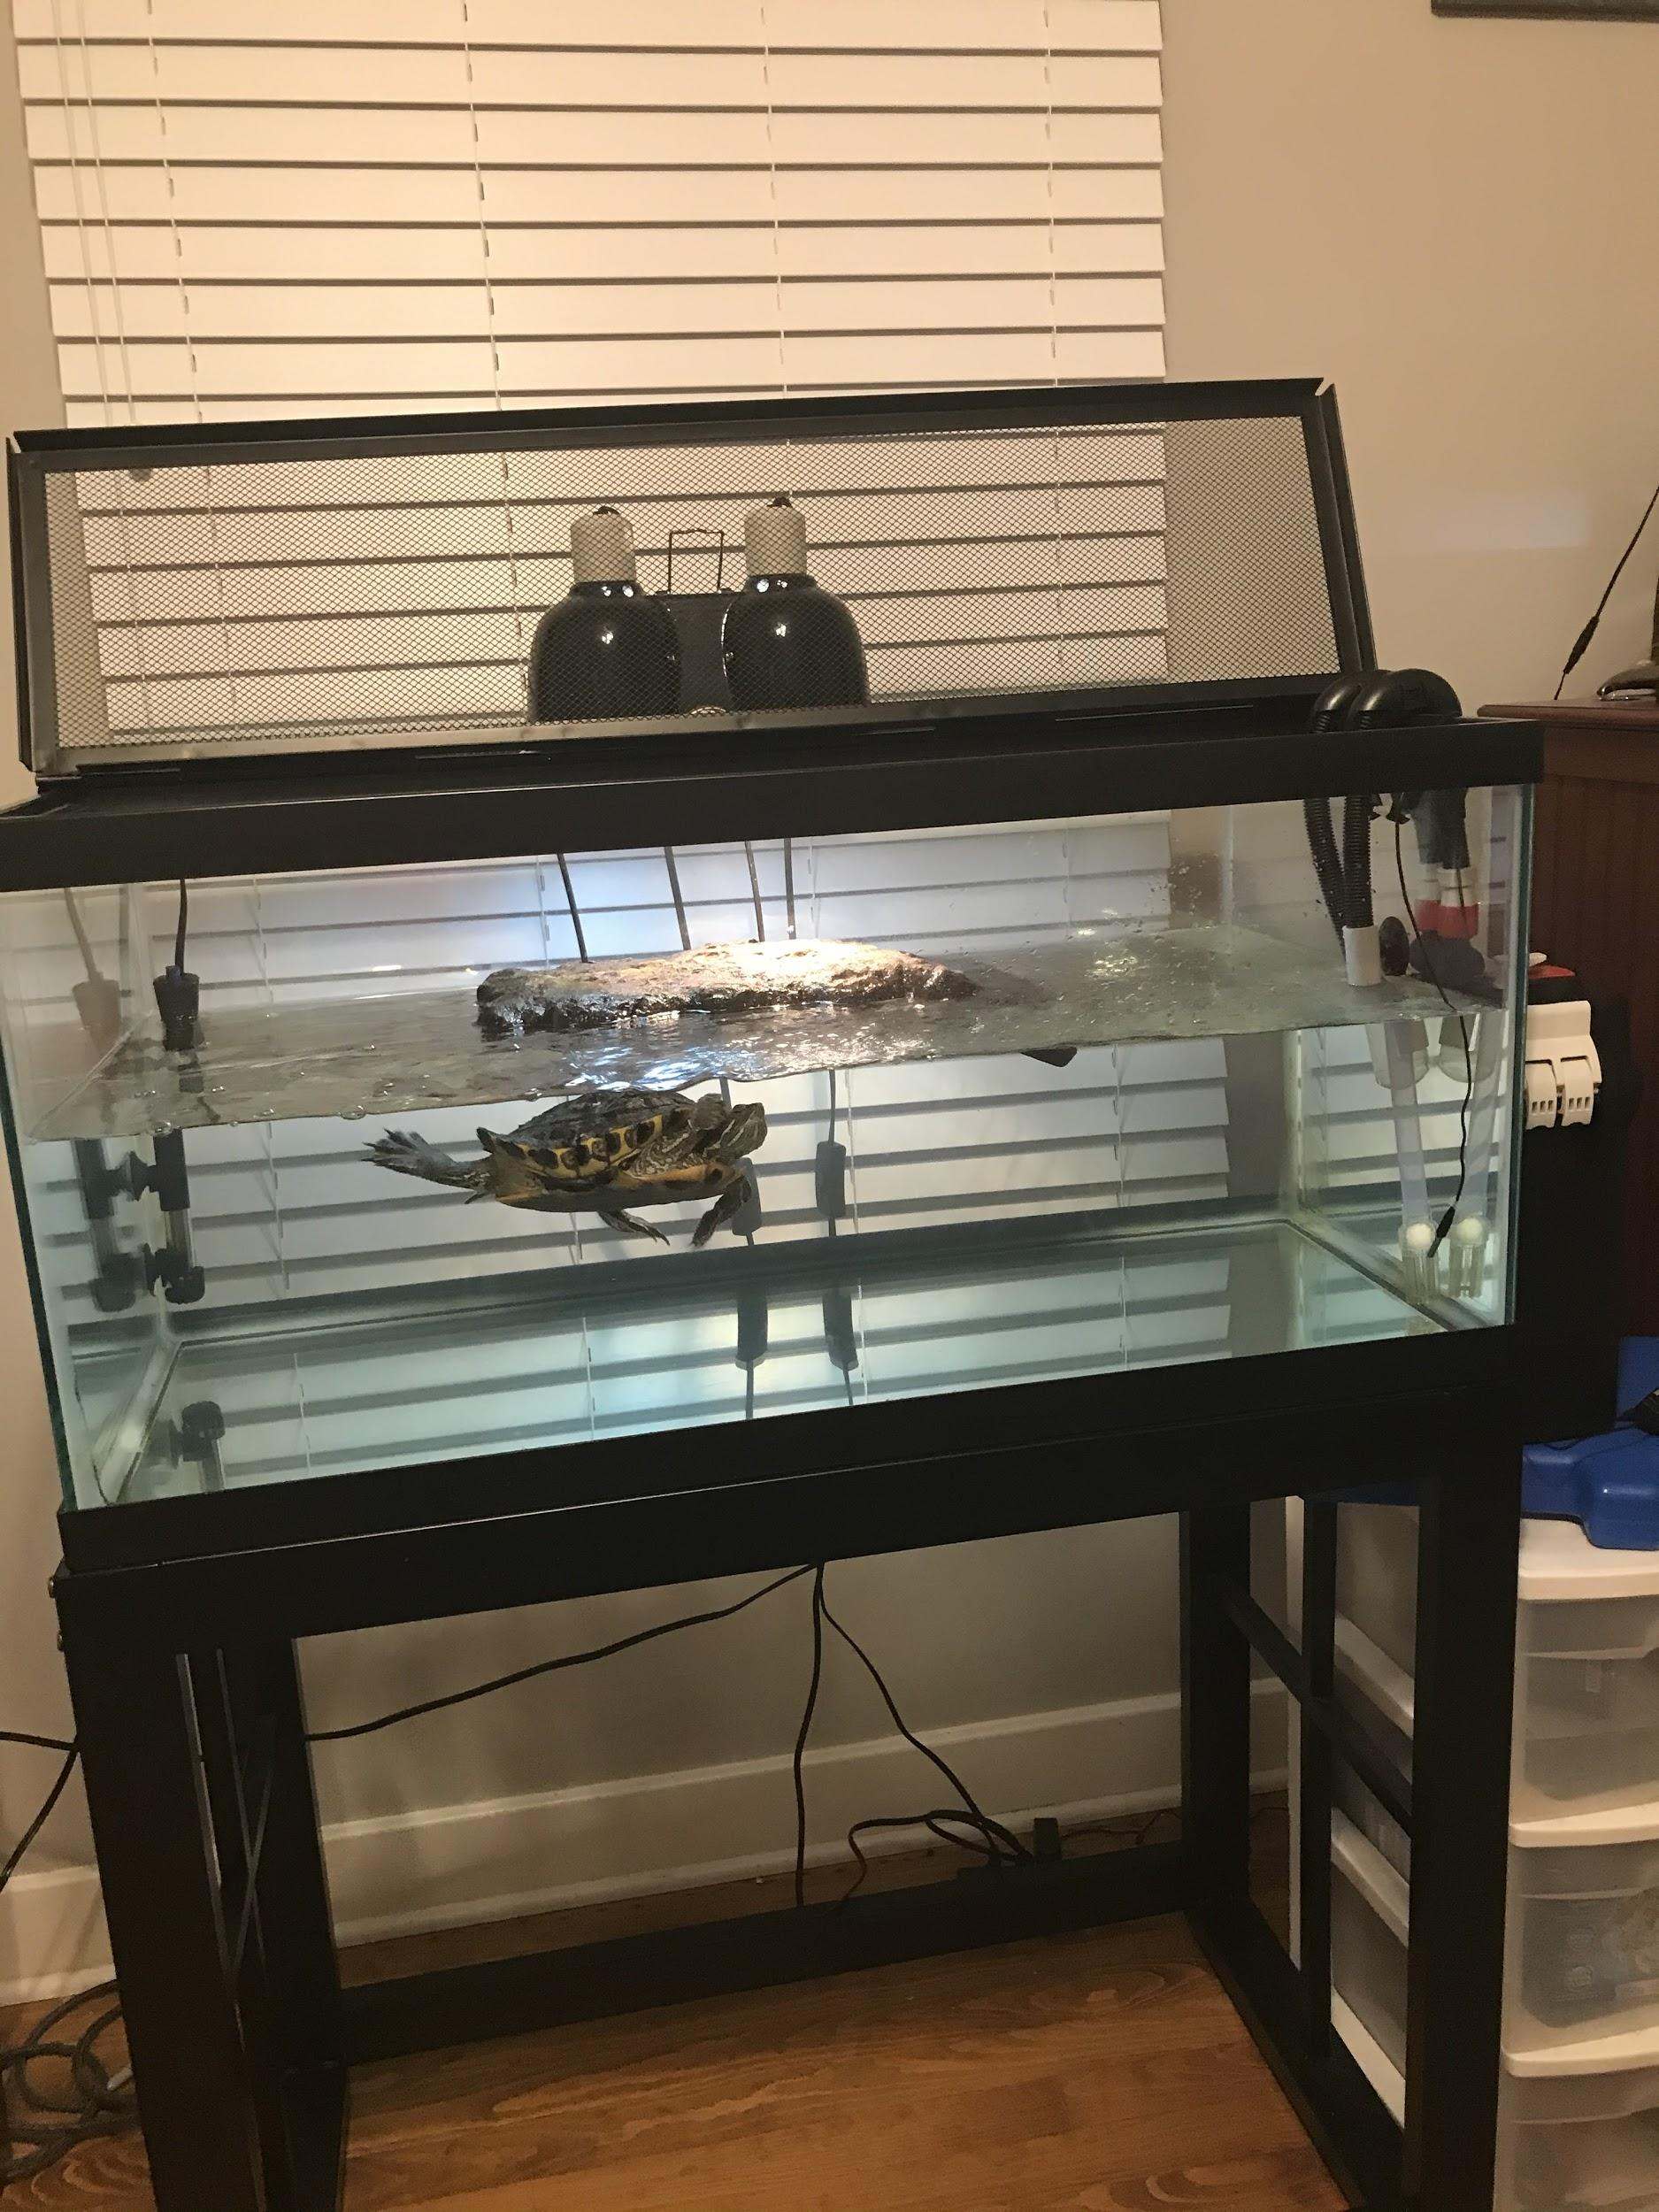

1. Filter

The best types of filters for turtles are canister filters. Turtles are very messy, so you will need a strong filter. The best filter is any Fluval Canister Filter. Get the right size filter for your tank.

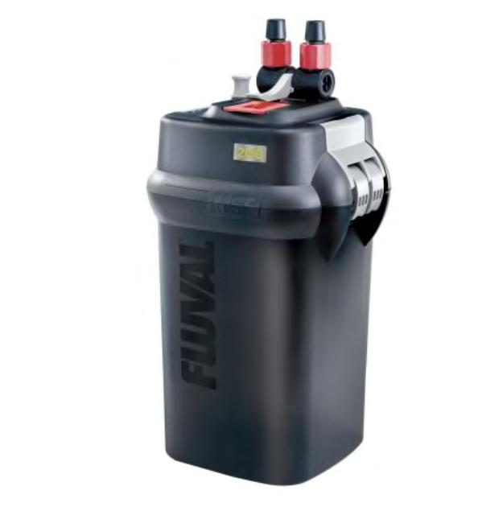

1. Heater and Thermometer

The best heater is any Aqueon heater. Get the right heater for your tank. Set the heater between 75 and 80 degrees fahrenheit. Any fish tank thermometer will work, but a good one is the Top Fin Digital Aquarium Thermometer. Never get a glass thermometer because your turtle could smash it and get hurt.

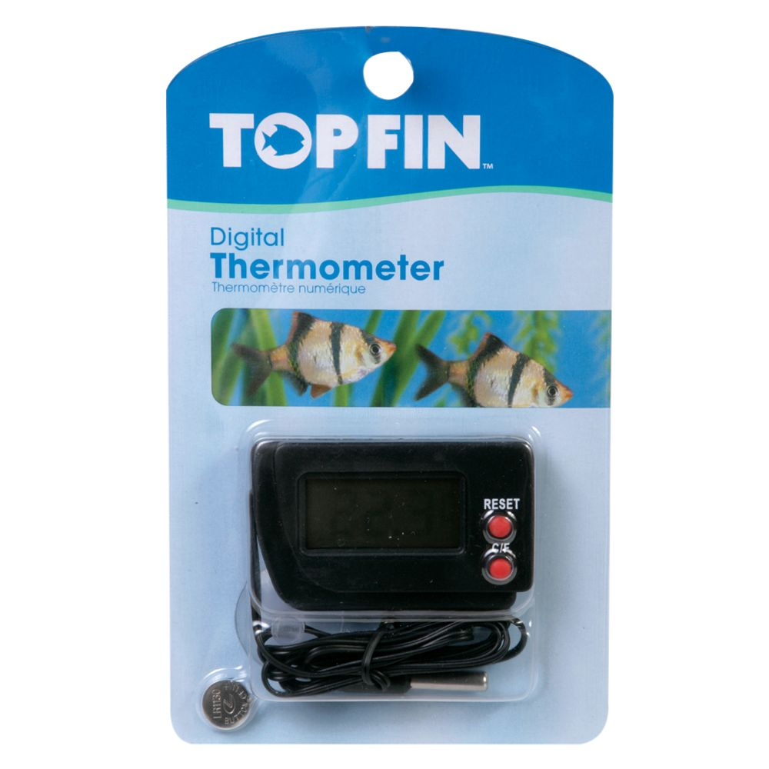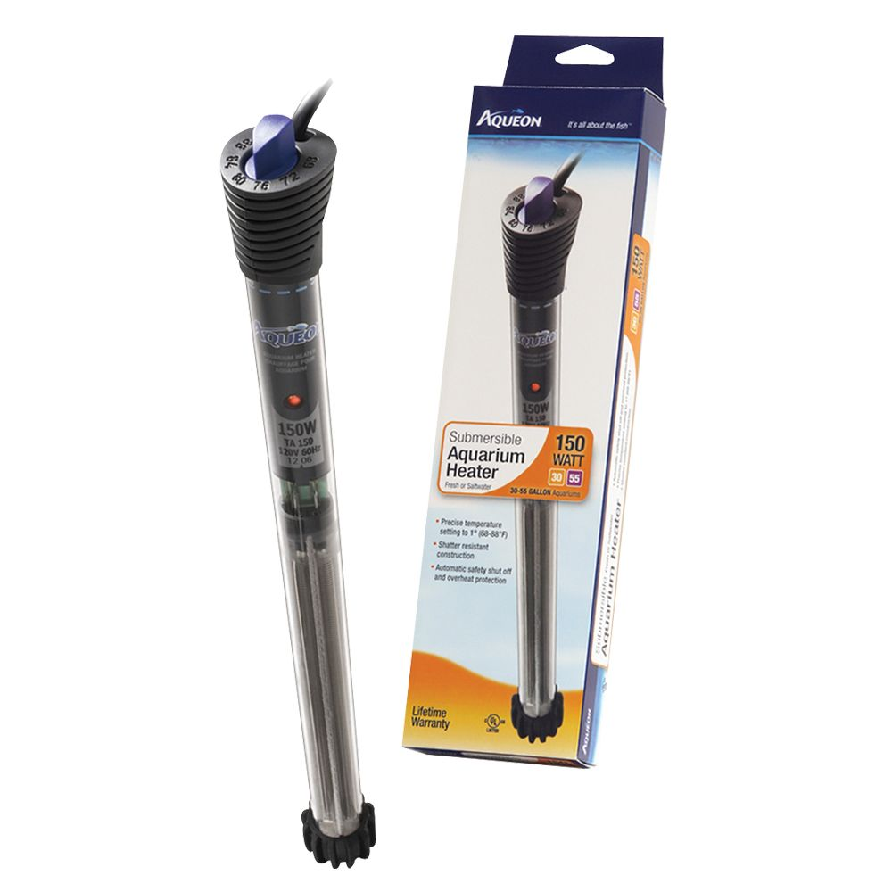

1. Lighting

Red eared sliders need UVB lights. A good light is the Zoo Med Aquatic Turtle UVB and Heat Lighting Kit. It is waterproof because turtles sometimes splash water. It also comes with the light bulbs you need.

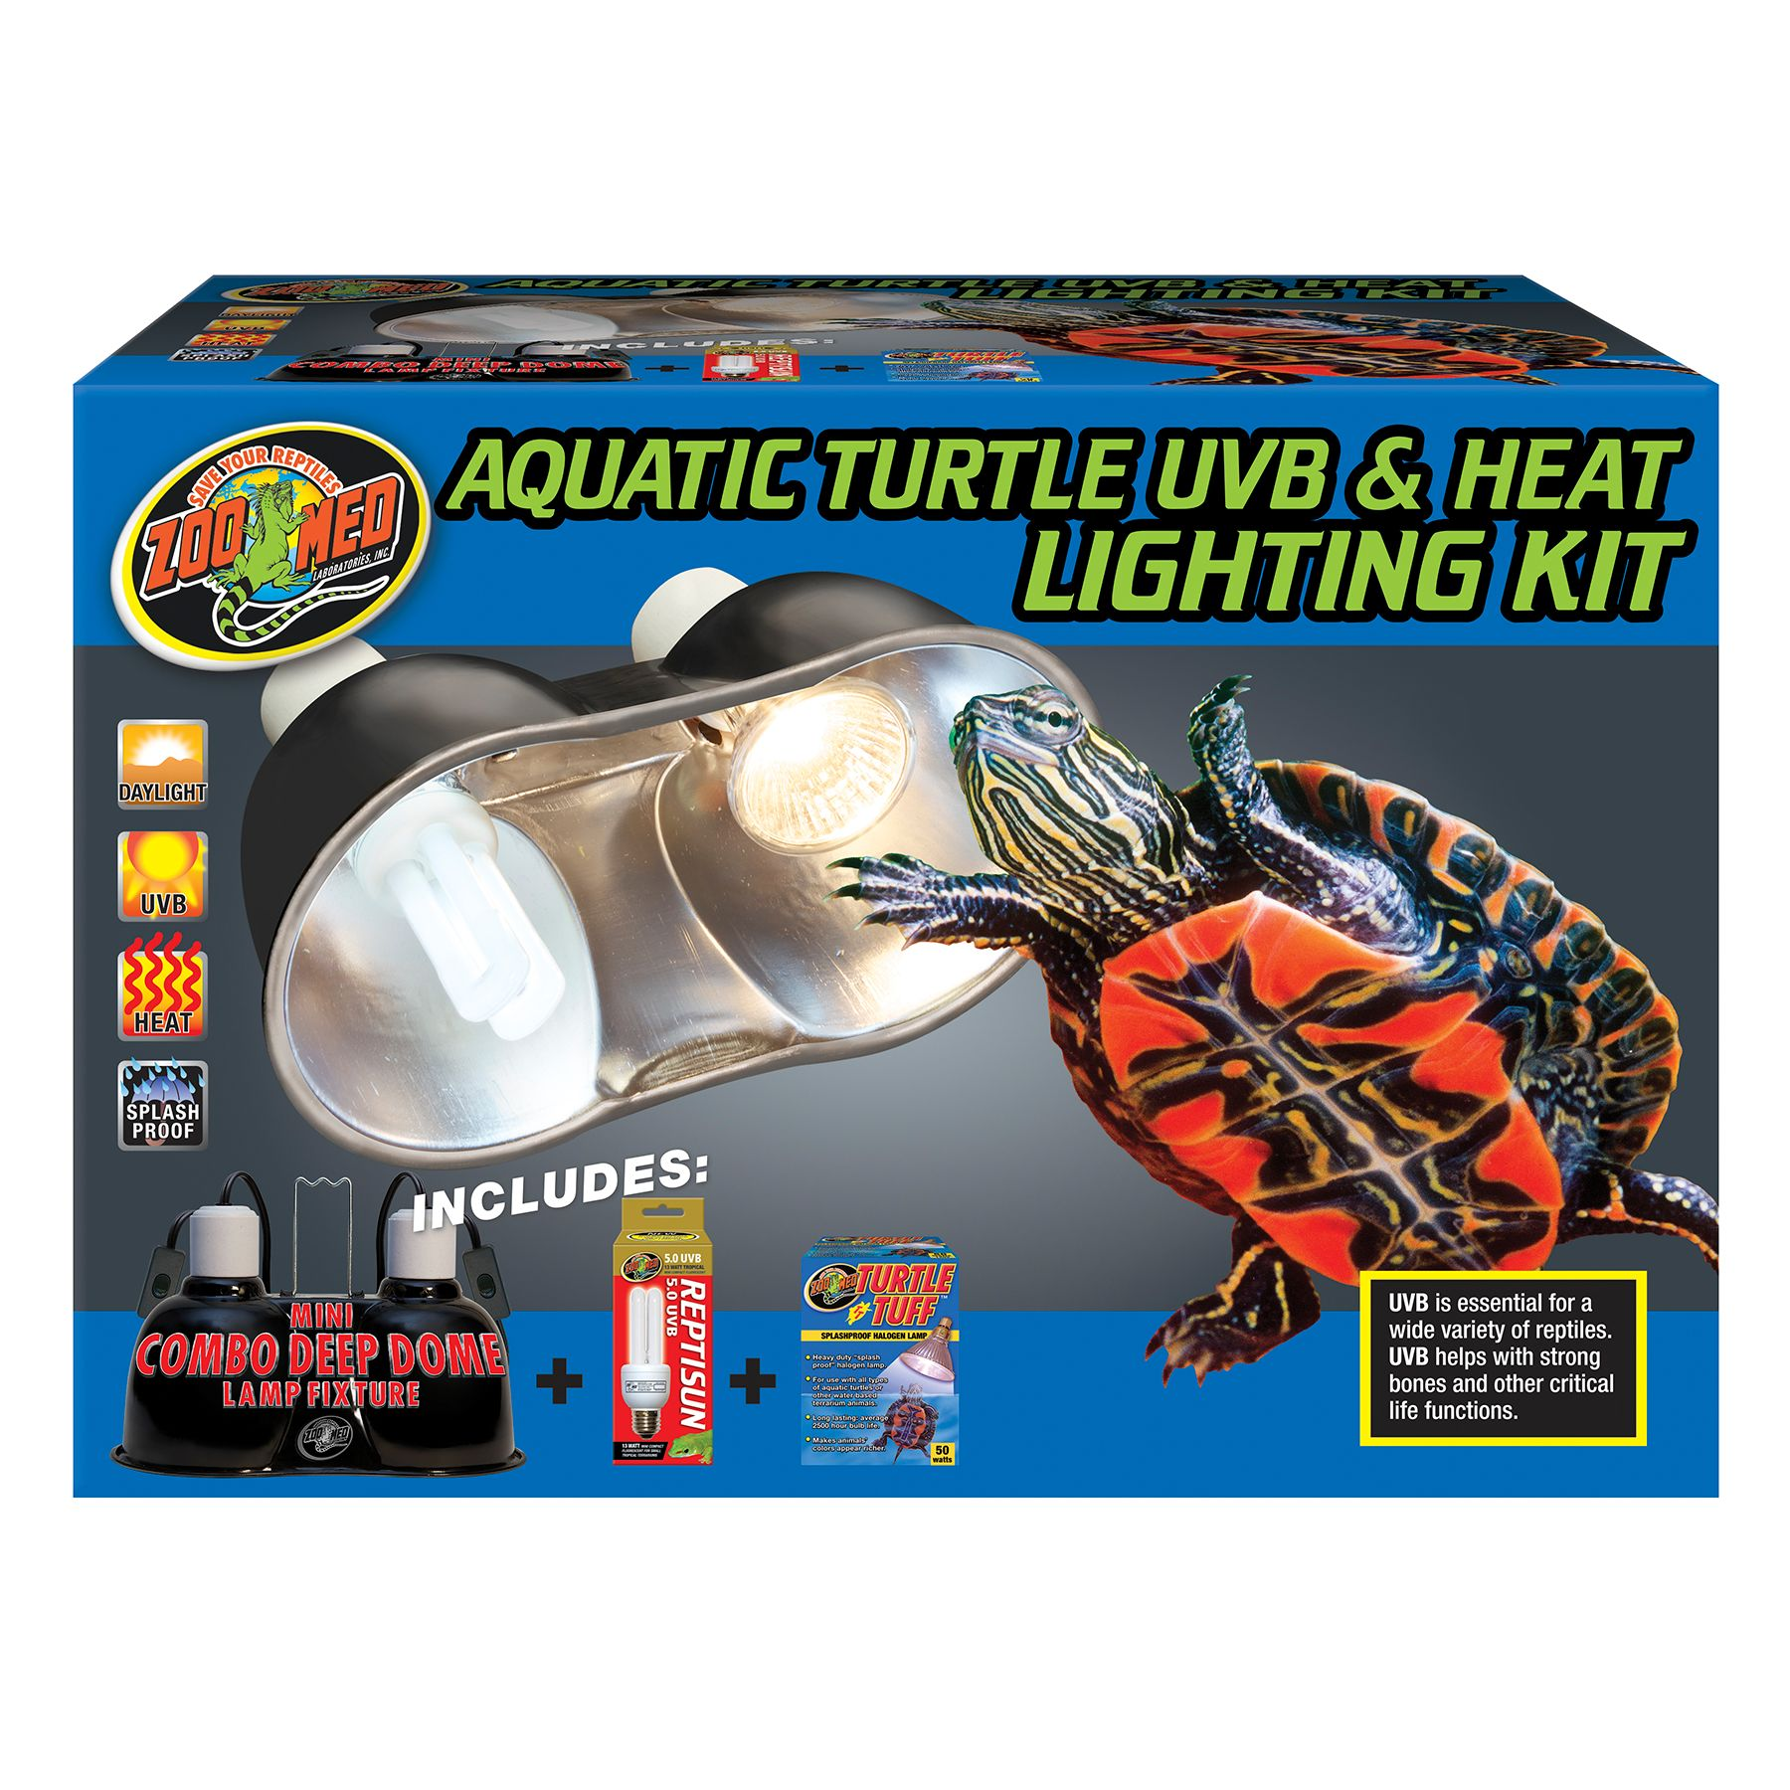

1. Lid and Dock

You should get a mesh lid for your turtle tank. Glass lids will not work because the heat from the lights has to go into the tank. Get the right size lid for your turtle. Turtles need a dock to bask on so they won't get shell rot or pneumonia. The best turtle dock is the Zoo Med Aquatic Floating Turtle Dock. Get the right size dock for your turtle.

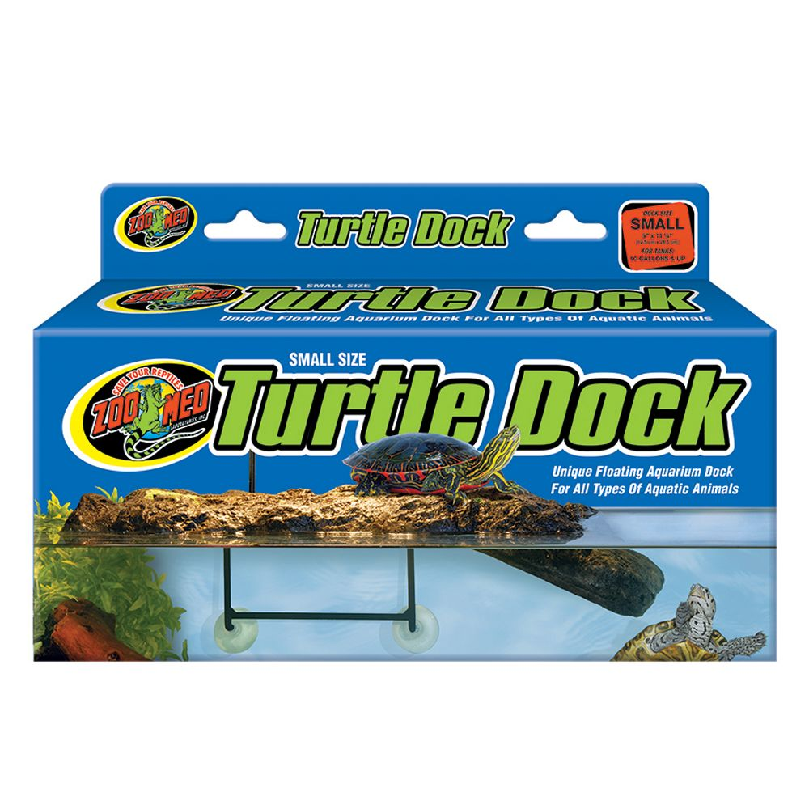

1. Siphon and water conditioners

You will need a siphon to change the water. A good siphon is the Imagitarium Aquatic Gravel Vacuum. It is the best siphon for turtles. A good water conditioner is API tap water control. Also get Fluker's Eco Clean Waste Remover to help clean the water.

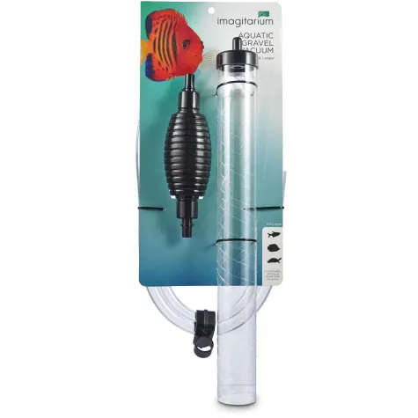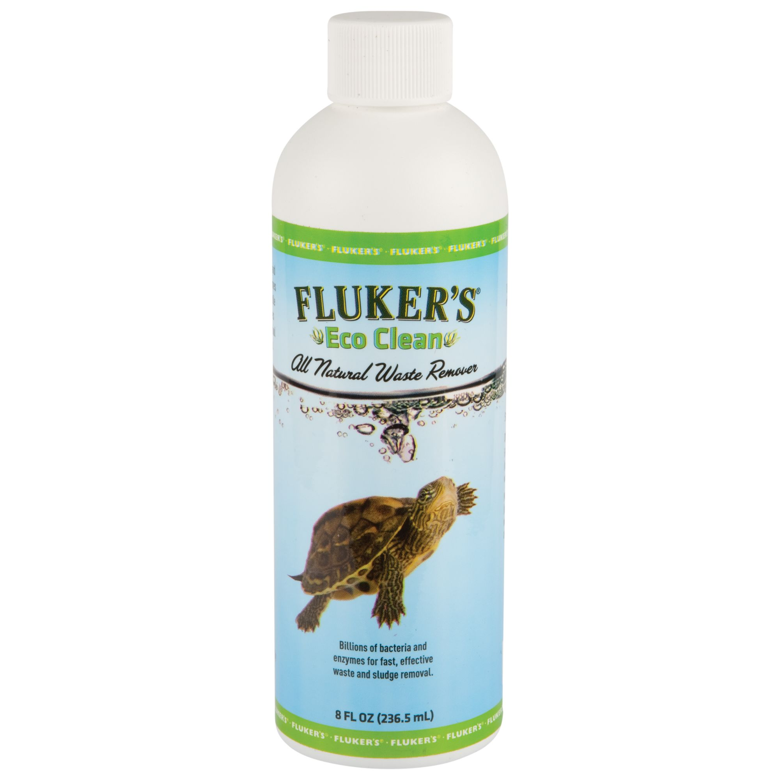

1. Food

Red eared sliders eat turtle pellets, freeze-dried shrimp, and live feeder minnows. Use fluker's freeze dried river shrimp and Zoo Med Natural Maintenance Formula Aquatic Turtle Food (turtle pellets). You can get feeder minnows at almost any pet store. Feed your turtle 5 turtle pellets every day if it is under 5 inches. If it is over 5 inches, feed it 10 turtle pellets a day. If you want, you can also give it 3 freeze dried river shrimp a day additional to the turtle pellets. Give your turtle feeder minnows once a week.

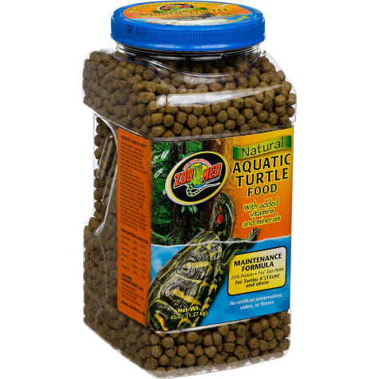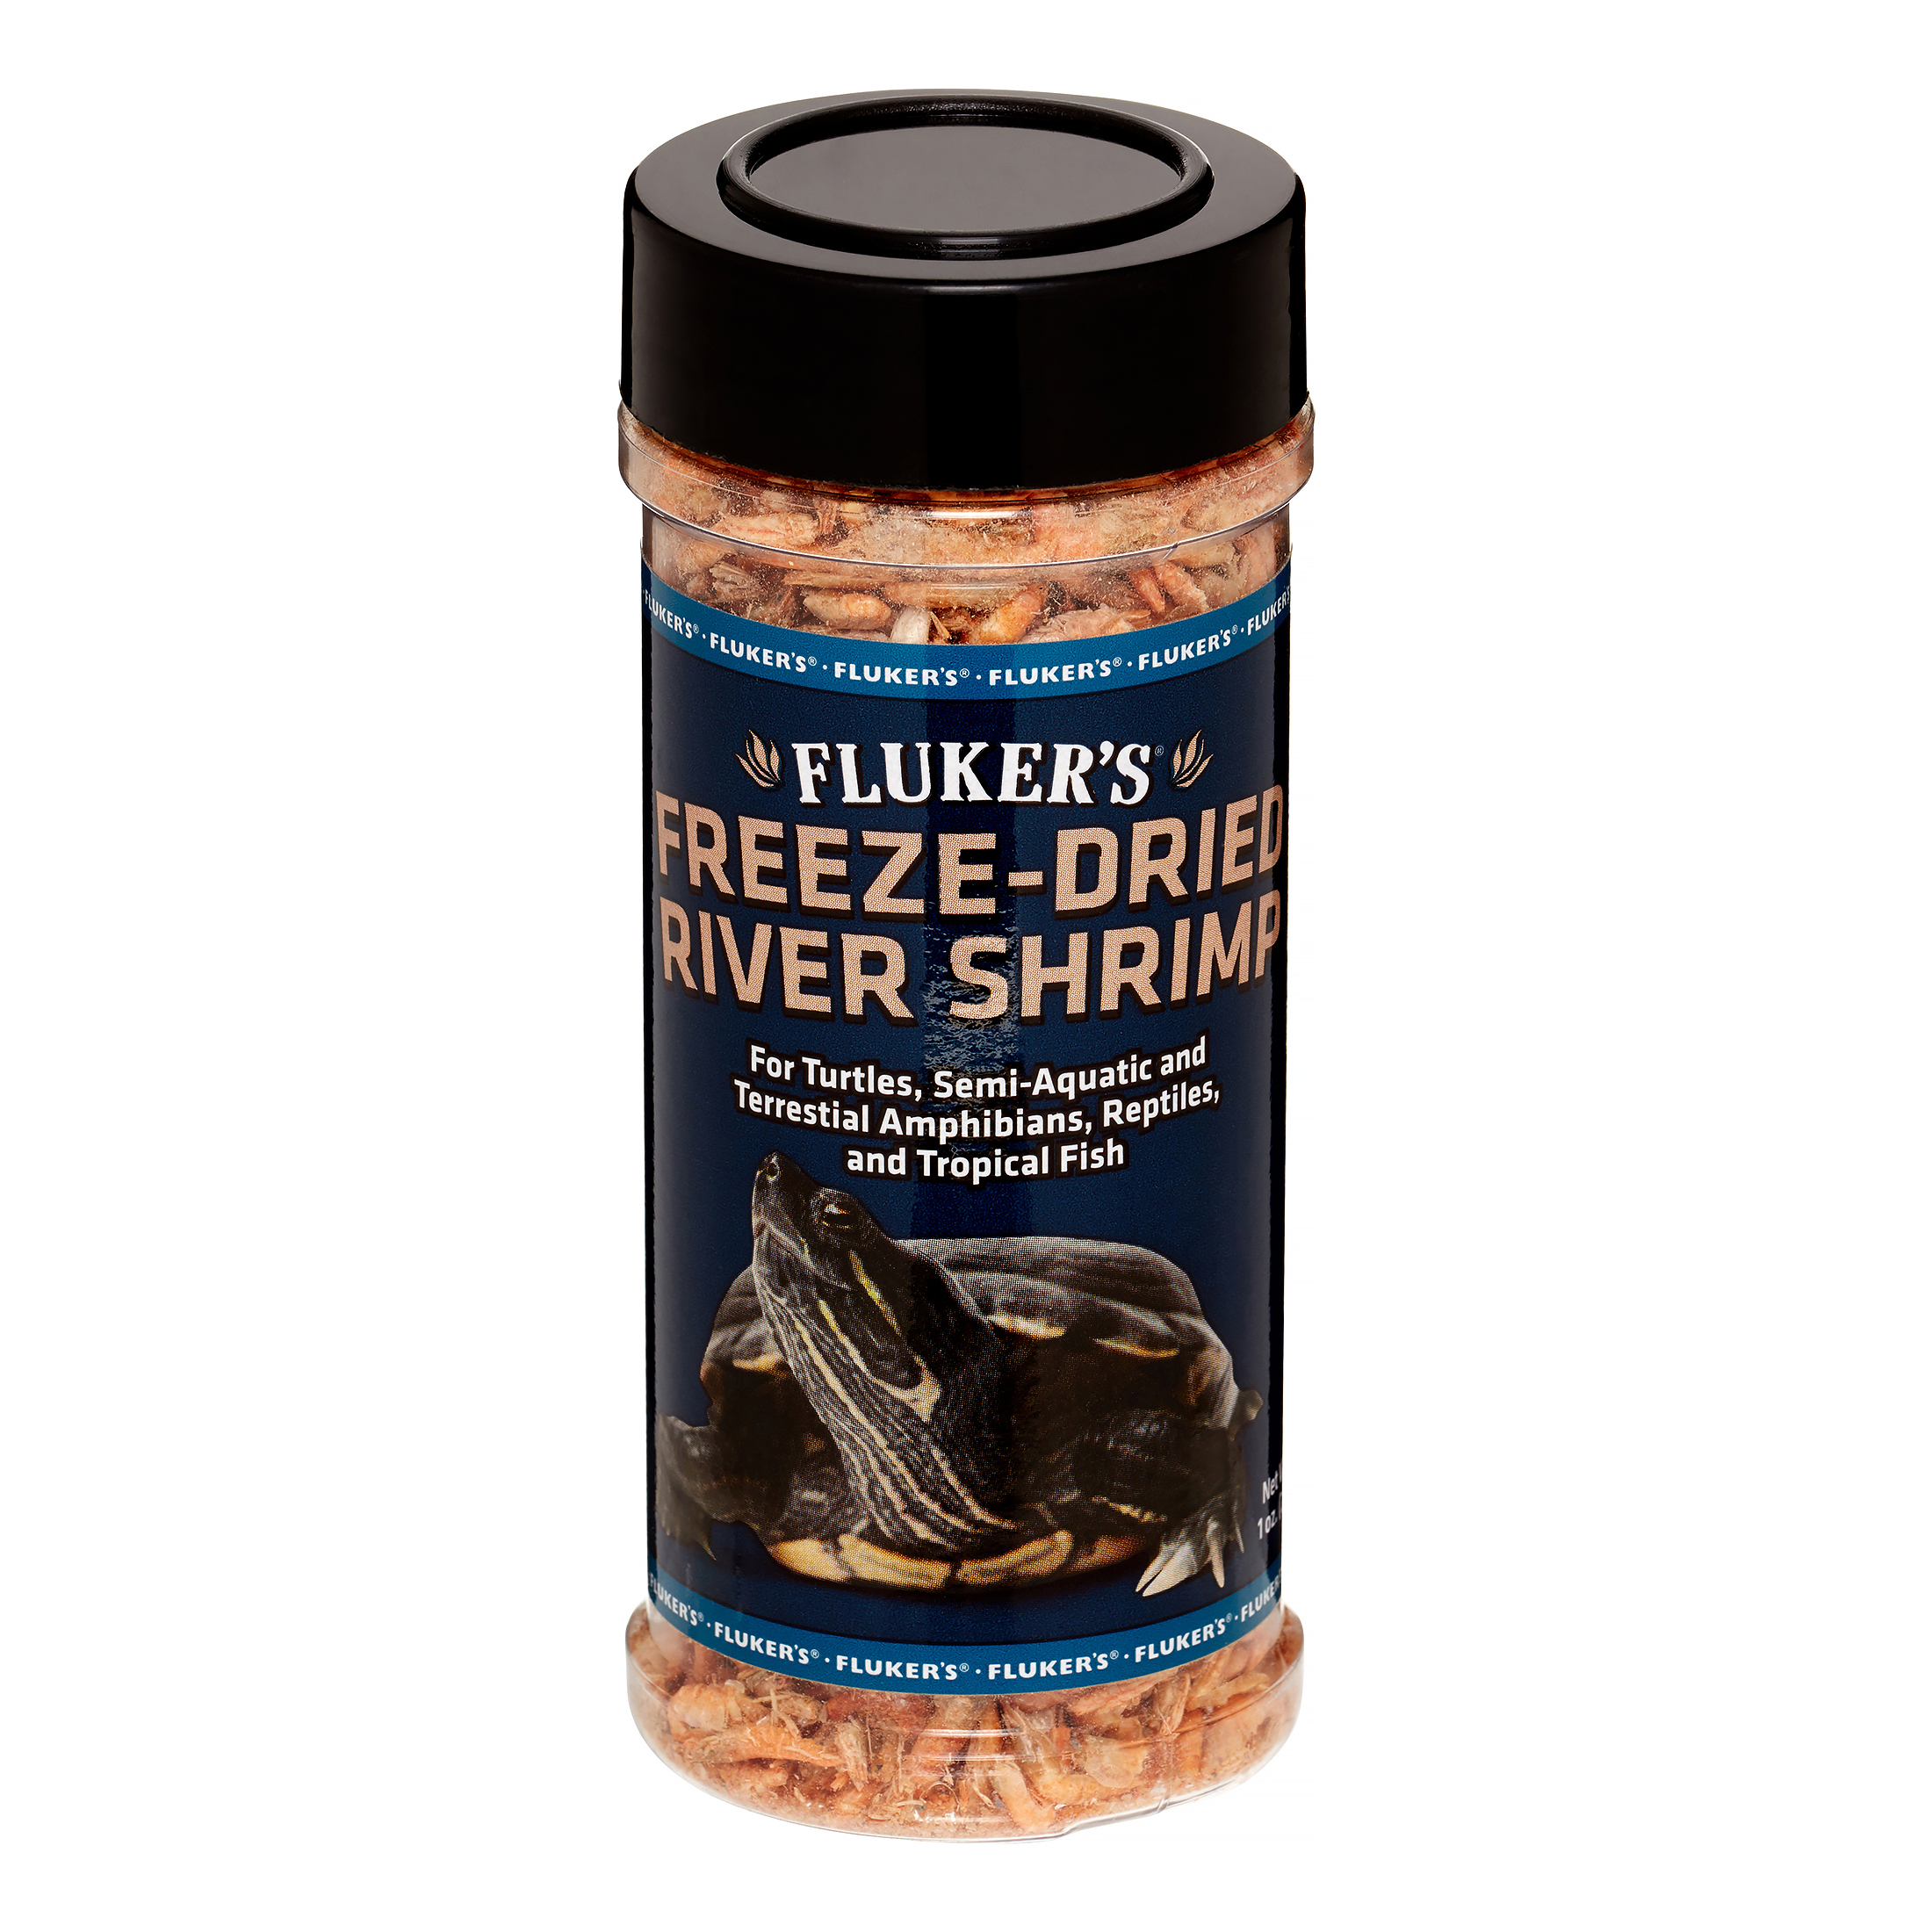

1. The Turtle

It is important to get your turtle from the right place. Never get a turtle from a big box pet store because they often don't take good care of their turtles. Get your turtle at a reptile show or a pet store that gets their turtles from a breeder.

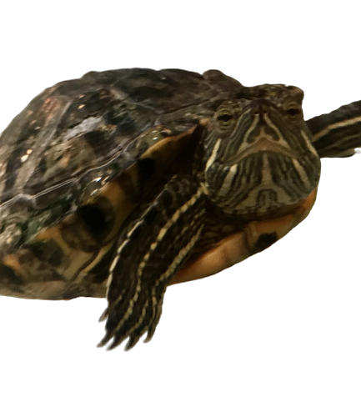

Zoe the turtle

Resources

[https://www.petco.com](https://www.petco.com/)

<https://www.petsmart.com>

[https://fluvalaquatics.com](https://fluvalaquatics.com/)

[https://zoomed.com](https://zoomed.com/)

[https://www.aqueon.com](https://www.aqueon.com/)